AGRICULTURE CROP PRODUCTION

1. INTRODUCTION

What is crop production? Crop production is the process of growing crops for domestic and commercial purposes. Some of the crops produced on a large scale include rice, wheat, maize, jute, etc

.

* 1. OVERVIEW

Agricultural production systems can be classified according to the following general categories: Subsistence farming. Smallholder farmers produce food (crops or livestock) for themselves and their families. Inputs, such as fertilizer and improved seeds, are often lacking, resulting in low productivity.

* 1. PURPOSE

Crop production is one of the fundamental branches of agriculture. Crop production is the basis for providing the livestock industry with feed, and the population with food

1. PROBLEM STATEMENT & DESIGN THINKING

Farmers face a lot of problems in agriculture right from nature's activities to man-made activities including climate change, soil erosion, biodiversity loss, water resource depletion, lack of capital, labour and other inputs etc.

Design thinking can be used to identify opportunities for innovation in regenerative farming practices, such as using cover crops to improve soil health or integrating livestock into crop rotations to improve nutrient cycling.

* 1. EMPATHY MAP

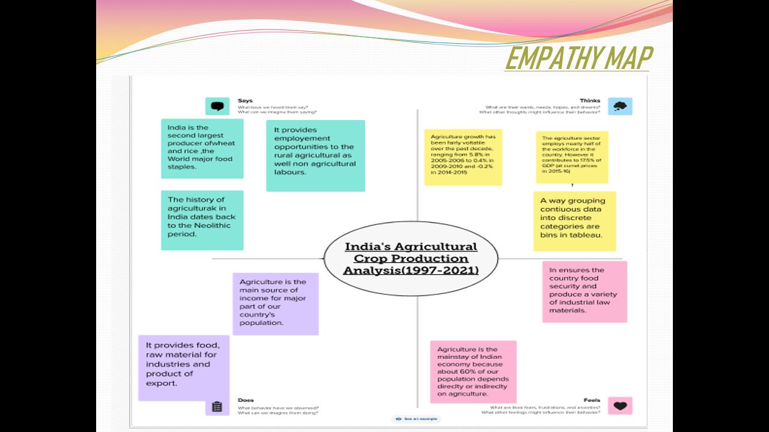

* 1. IDEATION & BRANSTORMING

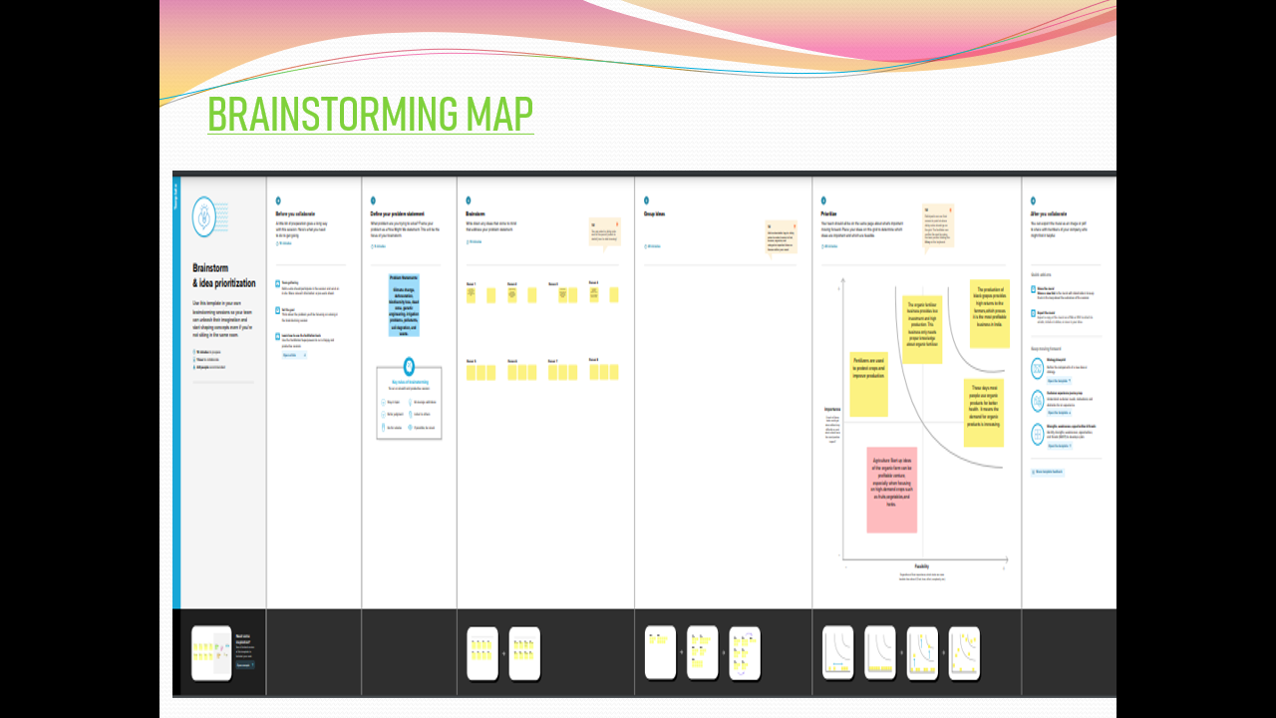

3.1 AREA VS PRODUCATION

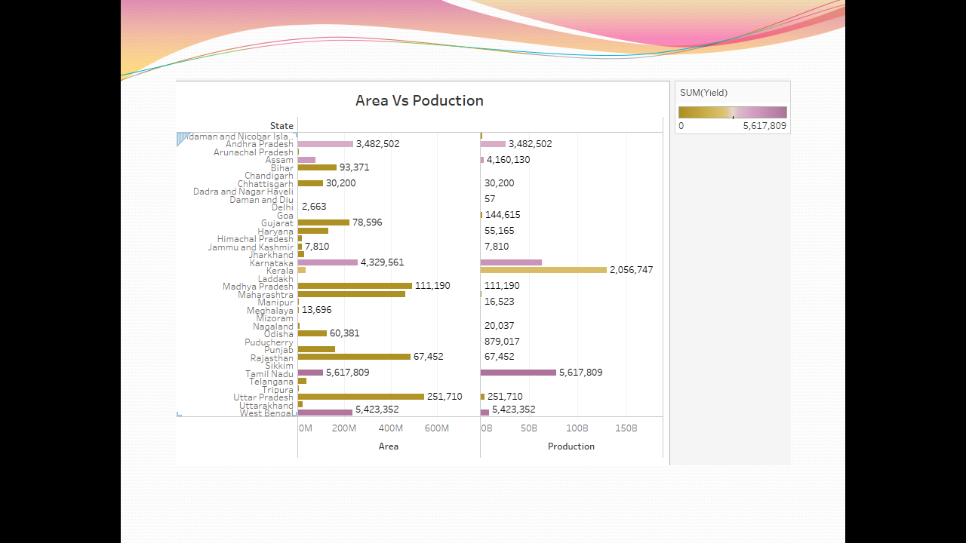

3.2 STATEWISE AGRICULTURAL LAND

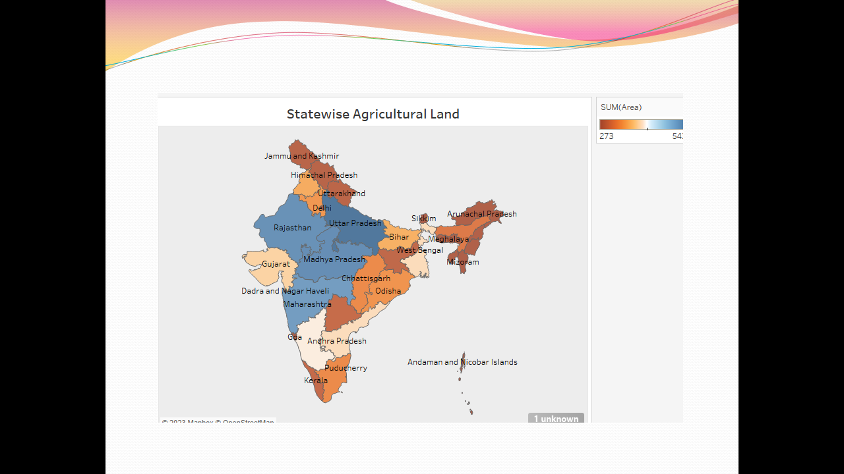

3.3 YIELD BY SEASON

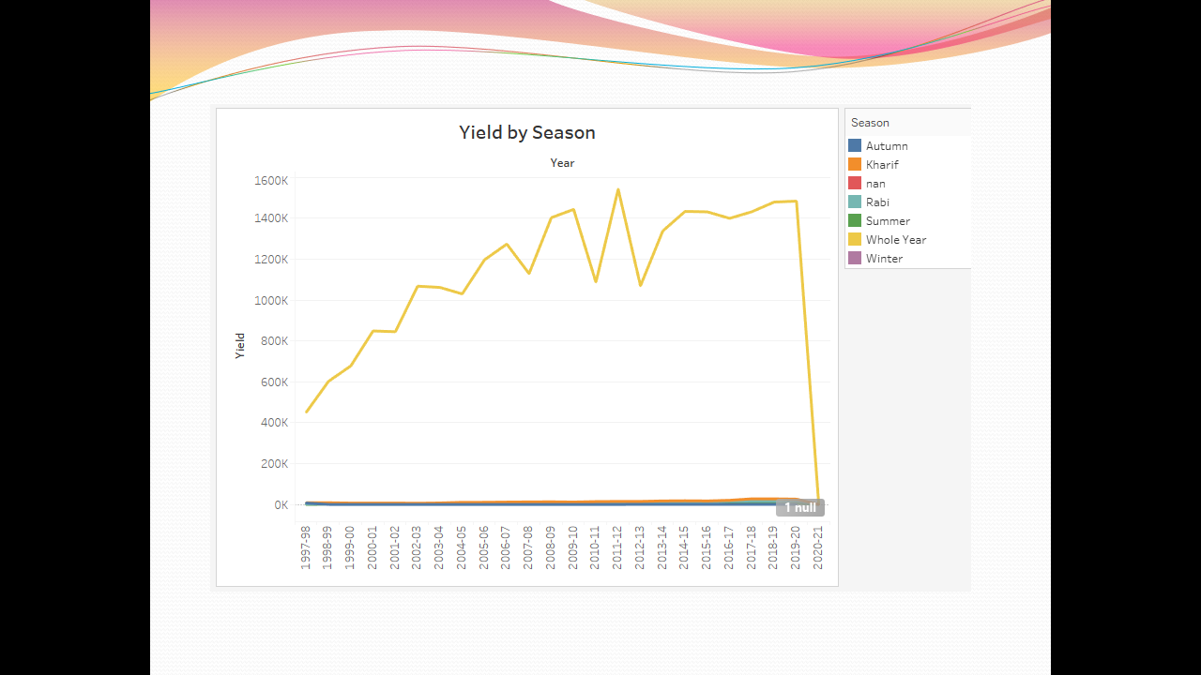

3.4 CROP PLANTATION BY AREA

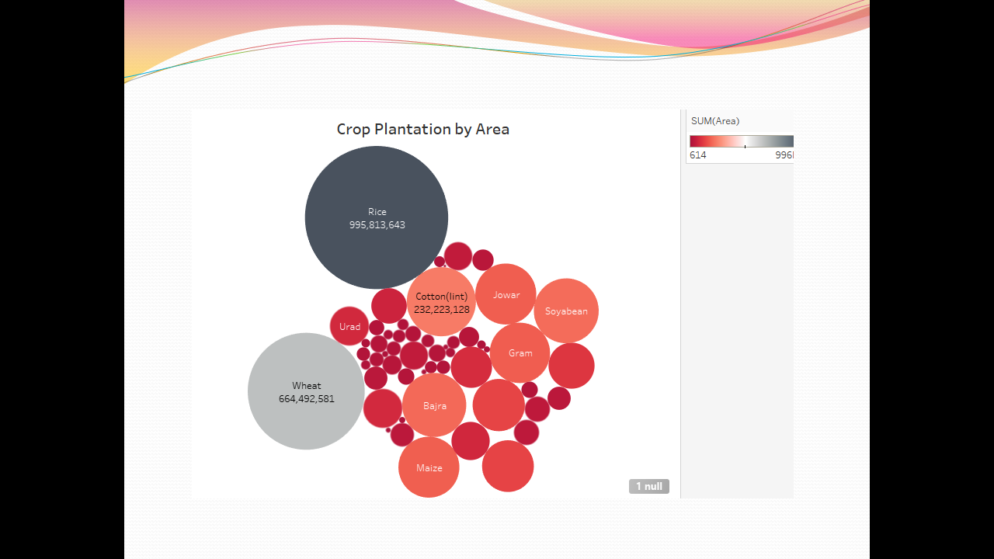

3.5 MAJOR CROP

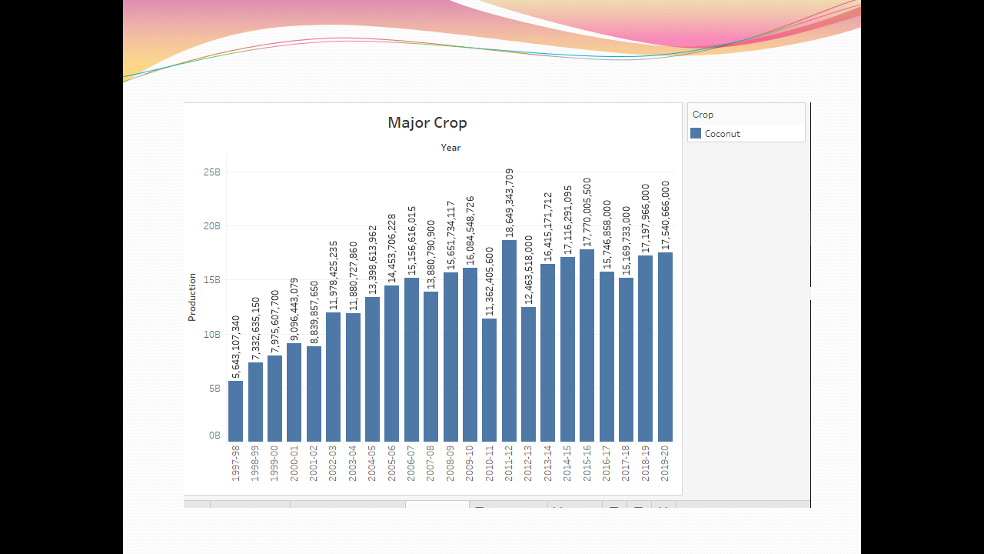

**4.DASHBOARD**

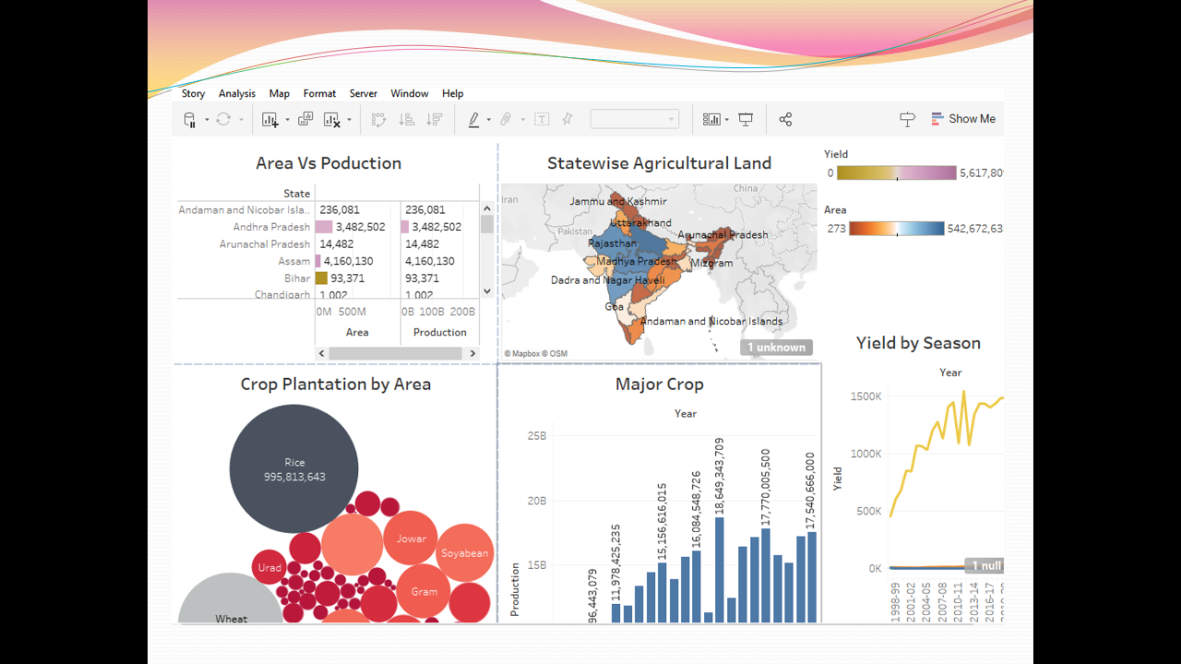

**4.STORY**

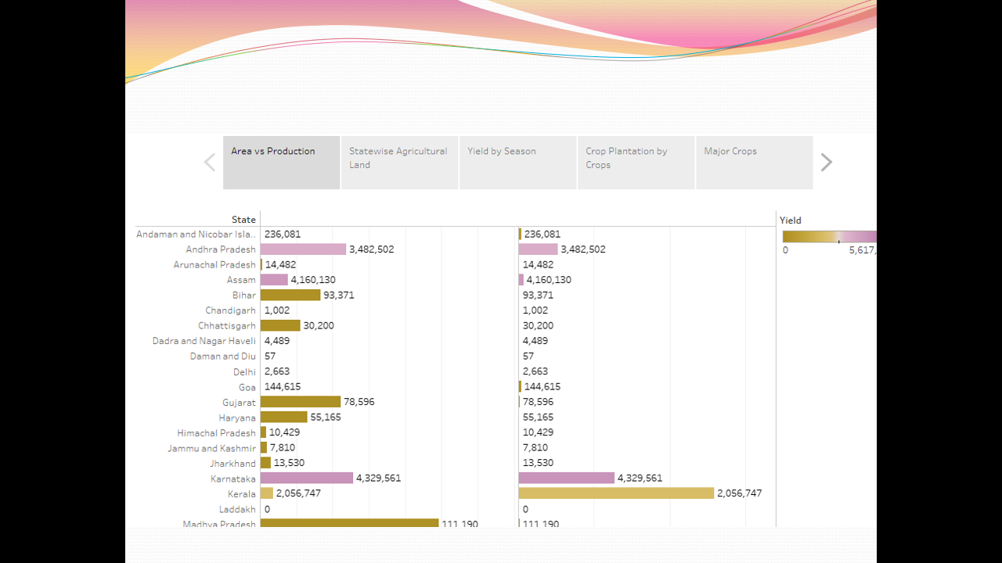

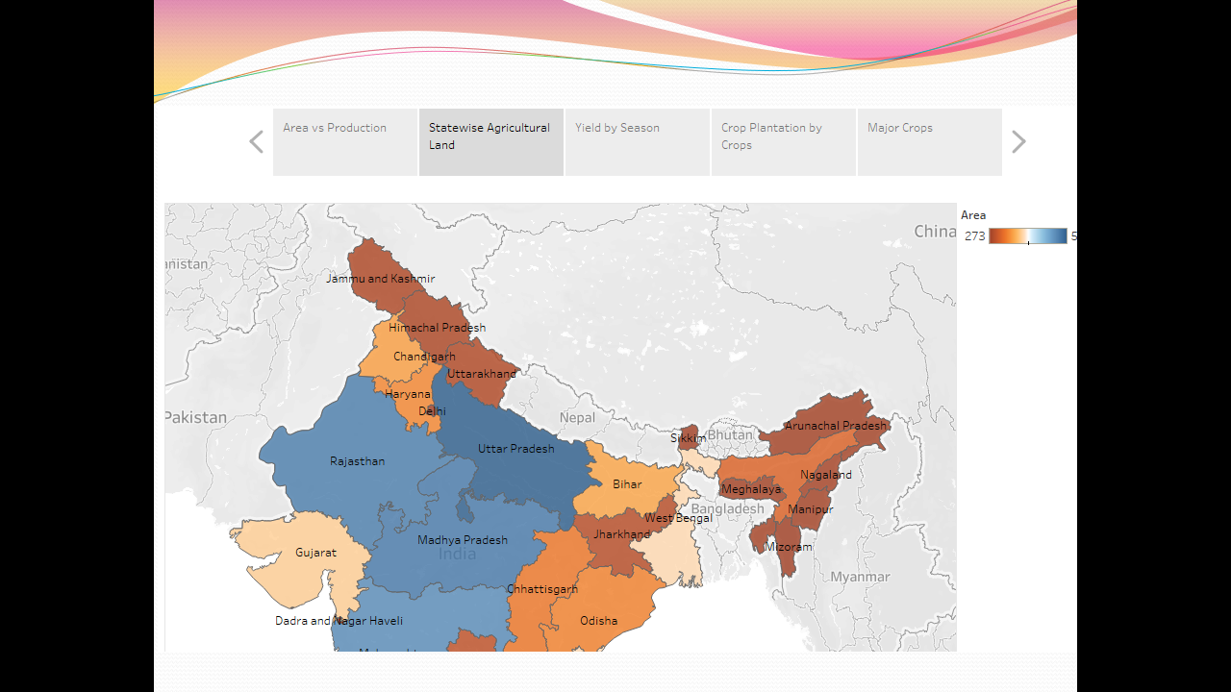

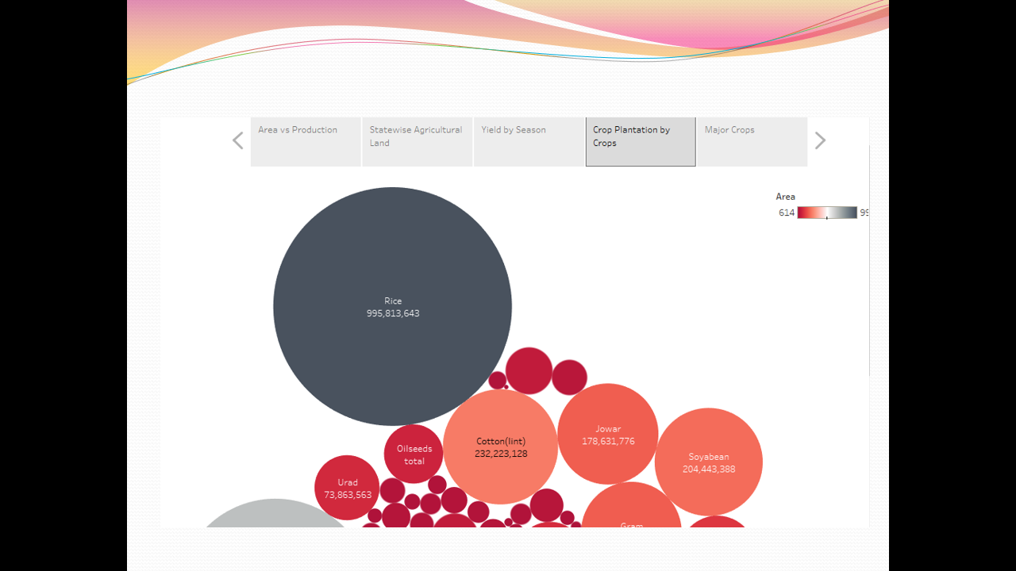

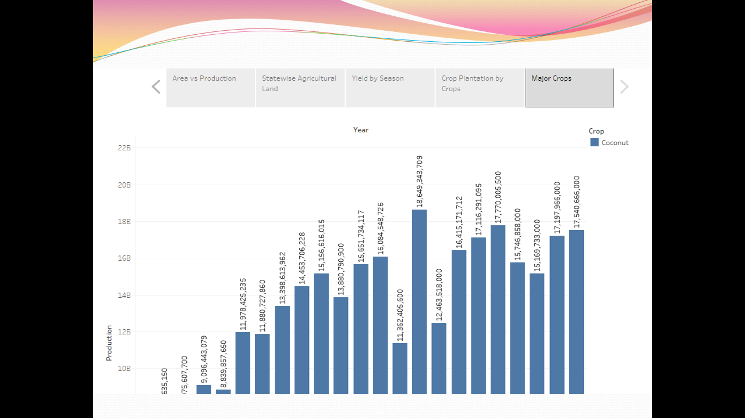

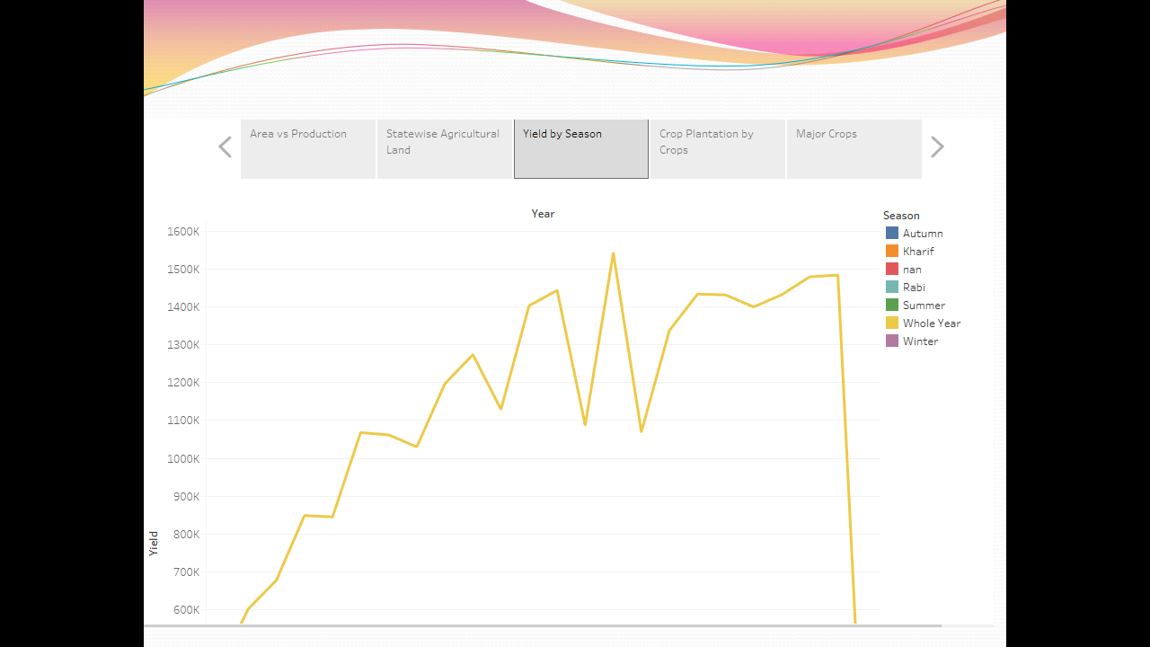

5. ADVANTAGE & DISADVANTAGE

ADVANTAGE

1. There is over all increase in yield of crops mainly due to maintaining physical- chemical properties of soil. Soil fertility is restored by fixing atmospheric nitrogen, encouraging microbial activity (more organic matter) and protecting soil from erosion, salinity and acidity.

2. It helps in controlling insects, pests and soil borne diseases. It also controls weeds. E.g. repeated wheat culture (growing) increases wild oats and phallaris infestation. Similarly growing berseem continuously encourages chicory (kasani) infestation, but an alternate cropping of berseem and wheat helps in controlling kasani as well as oats and phallaris.

3. Prevent or limit periods of peak requirements of irrigation water. Crops requiring high irrigation if followed by light irrigation, this will not affect or deteriorate the soil physical condition.

4. It facilitates even distribution of labour. Following crop make proper utilization of all resources and inputs. Family and farm labour, power, equipment and machines are well employed thought the year.

5. Farmers get a better price for his produce due to higher demand in local market. So there is regular flow of income over year.

DISADVANTAGES

* Deforestation. Intensive farming causes soil degradation and leads to the
* Pest and weed resistance to chemicals. ...
* Soil degradation. ...
* Impact on natural habitats. ...
* Water pollution. ...
* What are disadvantages of crop production?
* There is no insurance against crop failure i.e. the farmer cannot sell anything from animal section Incase there is crop failure , since it is
* crop that the farmer is based on. There is no diversification of farm produce. Crops may be attacked by pests and disease’s. Farmers have only one source of income.
* One disadvantage of crop rotation is that it involves risk. Despite high initial costs in machinery and different seedlings, the success of each rotation is not guaranteed. Additionally, diseases ana diseases from other crops used in rotation may infect other crops, adversely affecting production.
* This can lead to a decrease in ecosystem services and hamper agricultural production, ultimately affecting food security. Additionally, the conversion of agricultural land to non-agricultural uses, such as suburban development, can result in the loss of prime agricultural land. Property taxes, income taxes, and inheritance taxes also play a role in the conversion of agricultural land, as they can impact the organization and structure of American agriculture. Overall, agricultural land conversion poses a significant risk to food production, ecosystem services, and the sustainability of agricultural systems.

6.FUTURESCOPE

The corresponding increases have been less for non-basmati exports: 3.3% in value ($4.51 billion to $4.66 billion) and 4.6% in quantity (12.60 mt to 13.17 mt).

More spectacular perhaps is sugar. Sugar exports hit a record value of $4.60 billion in 2021-22, as against $2.79 billion, $1.97 billion, $1.36 billion, and $810.90 million in the preceding four fiscals.

This fiscal has seen a further surge of 43.6%, from $2.78 billion in April-December 2021 to $3.99 billion in April-December 2022.

India is an agrarian economy where people can augment their income by adopting hi tech farming methods. In fact, they should adopt industrial farming because India experiences all three seasons of summer, Winter & Rainy.

Its diverse climate sustains production of food grains, fruits, & vegetable that is crucial for food security.

India can become the biggest exporter of fruits & vegetables provided we develop hygienic storage facilities that mitigate production loss.

This offers tremendous scope for agriculture because we need skilled agriculturists who can develop an infrastructure for sustainable growth.

In 2021, the top exporters of Fruits were Thailand ($4.48B), New Zealand ($2.32B), Vietnam ($1.34B), Hong Kong ($892M), and Italy ($594M).

All these nations are much smaller compared to India, which highlights the tremendous potential in the agriculture sector.

Young Agriculture graduates can set up food parks, export units as the Government is offering subsidies for setting up the plant.

7.CONCULSION

The world is constantly changing, moving forward at a rapid paced, leaving the ways of the past behind. The agriculture industry is being left in the dust, while machines and technology take over the ways of the world. Being over shadowed by the new ways of life is having a negative impact on the agriculture industry. Urbanization is pushed out land, factories are compromising the quality of soil, and the working labor pool is getting smaller and smaller.

While all these negative things are happening, it’s not too late to combat the issues. So far we can reduce the loss of land by setting policies and implementing it as gardens in cites. We can set regulations on dumping and engineer new breeds of tolerant plant crops. We can put in place laws that benefit those workers who are willing to pursue a career in the industry. These are just some of the ways we can combat these issues. As we keep advancing, we can advance new ways to fix all these problems, but we have to do it fast. The agriculture industry is one that needs to be preserved in order to sustain life. Without agriculture there would be no food, and without food there would be nothing.